Batch: E-2 Roll No.: 16010123325

Experiment / assignment / tutorial No. 7
Grade: AA / AB / BB / BC / CC / CD /DD
Signature of the Staff In-charge with date

Title: Indexing - Create Index and observe the evaluation statistics of
query execution with and without Index

Objective: Implement indexing to improve query execution plans

Expected Outcome of Experiment:
CO 4: Analyse Advanced Database Concepts like indexing, hashing, query processing, query optimization, normalization.

Books/ Journals/ Websites referred:

1. Dr. P.S. Deshpande, SQL and PL/SQL for Oracle 10g.Black book, Dreamtech Press
2. www.db-book.com
3. Korth, Slberchatz, Sudarshan : “Database Systems Concept”, 5th Edition , McGraw
Hill
4. Elmasri and Navathe,”Fundamentals of database Systems”, 4th Edition,PEARSON
Education.

Resources used: PostgreSQL

Theory:

A database index is a data structure that improves the speed of operations in a table. Indexes can be created using one or more columns, providing the basis for both rapid random lookups and efficient ordering of access to records.

While creating index, it should be taken into consideration which all columns will be used to make SQL queries and create one or more indexes on those columns.
To add an index for a column or a set of columns, you use the CREATE INDEX statement as follows:
CREATE INDEX index_name ON table_name (column_list)

Query life cycle

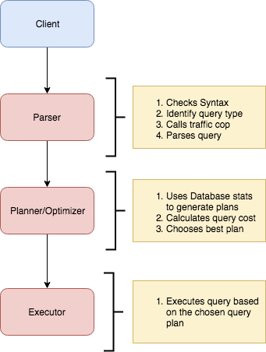

Planner and Executor:
The planner receives a query tree from the rewriter and generates a (query) plan tree that can be processed by the executor most effectively.
The planner in Database is based on pure cost-based optimization -

EXPLAIN command:
This command displays the execution plan that the PostgreSQL/MySQL planner generates for the supplied statement. The execution plan shows how the table(s) referenced by the statement will be scanned — by plain sequential scan, index scan, etc. — and if multiple tables are referenced, what join algorithms will be used to bring together the required rows from each input table.
As in the other RDBMS, the EXPLAIN command in Database displays the plan tree itself. A specific example is shown below:-

Database: testdb=#
- EXPLAIN SELECT * FROM tbl_a WHERE id < 300 ORDER BY data;
- QUERY PLAN
- ---------------------------------------------------------------
- Sort (cost=182.34..183.09 rows=300 width=8)
- Sort Key: data
- -> Seq Scan on tbl_a (cost=0.00..170.00 rows=300 width=8)
- Filter: (id < 300)
- (4 rows)

A simple plan tree and the relationship between the plan tree and the result of the EXPLAIN command in PostgreSQL.
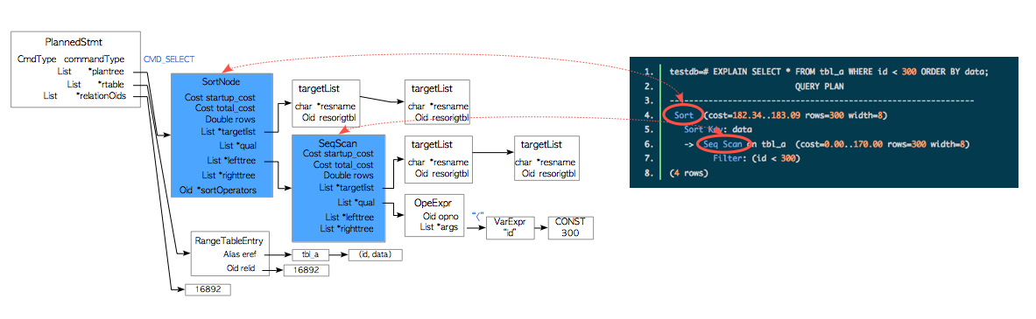

Nodes
The first thing to understand is that each indented block with a preceeding “->” (along with the top line) is called a node. A node is a logical unit of work (a “step” if you will) with an associated cost and execution time. The costs and times presented at each node are cumulative and roll up all child nodes.

Cost:
It is not the time but a concept designed to estimate the cost of an operation. The first number is start-up cost (cost to retrieve first record) and the second number is the cost incurred to process entire node (total cost from start to finish).
Cost is a combination of 5 work components used to estimate the work required: sequential fetch, non-sequential (random) fetch, processing of row, processing operator (function), and processing index entry.

Rows are the approximate number of rows returned when a specified operation is performed.
(In the case of select with where clause rows returned is
Rows = cardinality of relation * selectivity )
Width is an average size of one row in bytes.

Explain Analyze command:
The EXPLAIN ANALYZE option causes the statement to be actually executed, not only planned. Then actual run time statistics are added to the display, including the total elapsed time expended within each plan node (in milliseconds) and the total number of rows it actually returned. This is useful for seeing whether the planner's estimates are close to reality.
Ex: EXPLAIN (ANALYZE) SELECT * FROM foo;
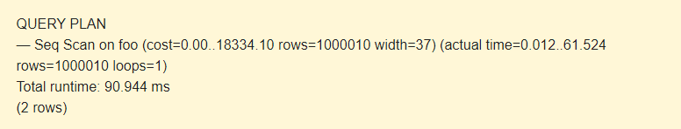
The command displays the following additional parameters:
- actual time is the actual time in milliseconds spent to get the first row and all rows, respectively.
- rows is the actual number of rows received with Seq Scan.
- loops is the number of times the Seq Scan operation had to be performed.
- Total runtime is the total time of query execution.
Query plans for select with where clause can be sequential scan, Index Scan, Index only Scan, Bitmap Index Scan etc.
Query plans for joins are Nested loop join, Hash join, Merge join etc.

Indexing: CREATE INDEX constructs an index on the specified column(s) of the specified relation, which can be a table or a materialized view. Indexes are primarily used to enhance database performance (though inappropriate use can result in slower performance).
Syntax
CREATE [ UNIQUE ] INDEX [ CONCURRENTLY ] [ [ IF NOT EXISTS ] name ] ON [ ONLY ] table_name [ USING method ]
( { column_name | ( expression ) } [ COLLATE collation ] [ opclass [ ( opclass_parameter = value [, ... ] ) ] ] [ ASC | DESC ] [ NULLS { FIRST | LAST } ] [, ...] )
[ INCLUDE ( column_name [, ...] ) ]
[ NULLS [ NOT ] DISTINCT ]
[ WITH ( storage_parameter [= value] [, ... ] ) ]
[ TABLESPACE tablespace_name ]
[ WHERE predicate ]

example
explain Analyse select * from std2 where branch ='ext'
create index dept on std2(Branch)
select * from std2
explain Analyse select * from std2 where branch ='ext'
drop index dept
Implementation Screenshots :
Comprehend how indexes improves the performance of query applied for your database . Demonstrate for the following types of query on your database
  - Simple select query
  - Select query with where clause
  - Select query with order by query
  - Select query with JOIN
  - Select query with aggregation

CREATE TABLE users (
id SERIAL PRIMARY KEY,
name TEXT,
email TEXT
);

INSERT INTO users (name, email) VALUES
('Alice', 'alice@example.com'),
('Bob', 'bob@example.com'),
('Charlie', 'charlie@example.com');

EXPLAIN ANALYZE SELECT * FROM users WHERE name = 'Alice';

CREATE INDEX idx_users_name ON users (name);

EXPLAIN ANALYZE SELECT * FROM users WHERE name = 'Alice';

  - Simple select query

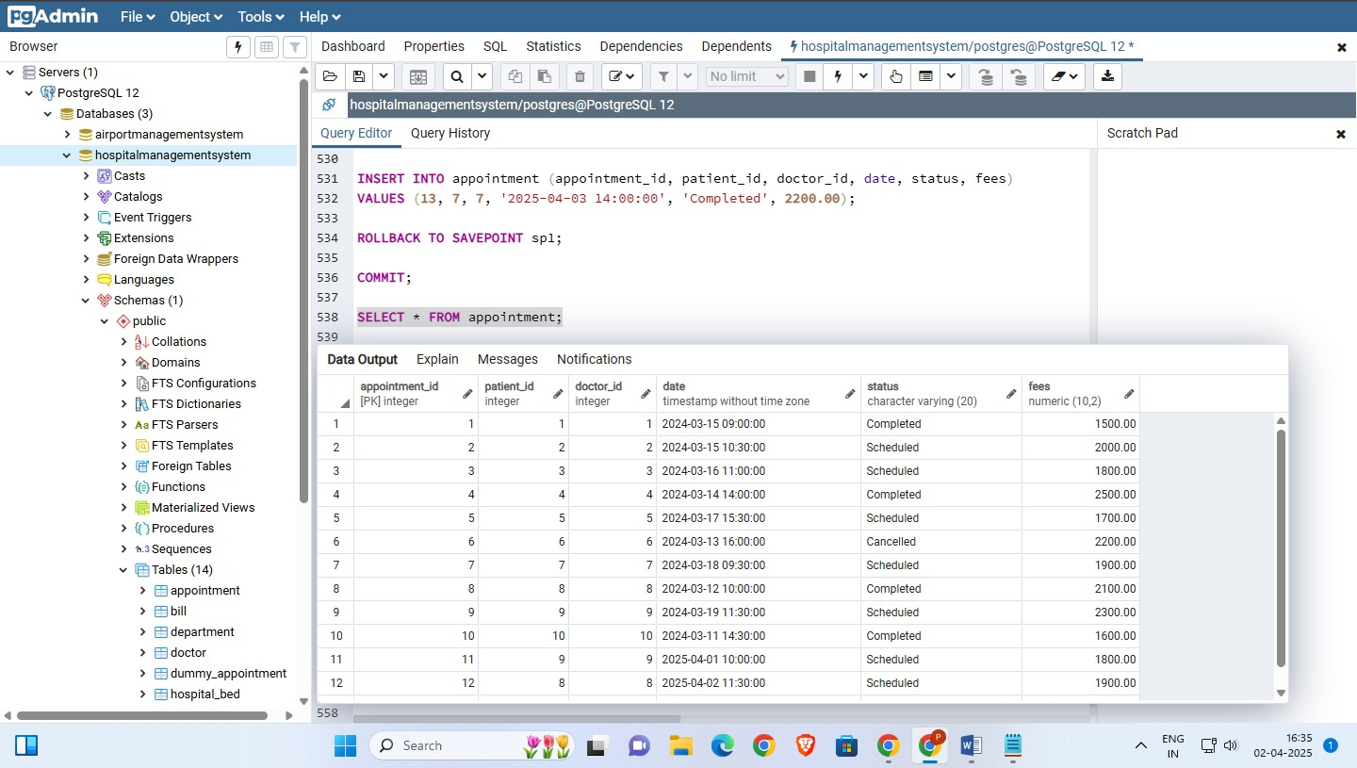

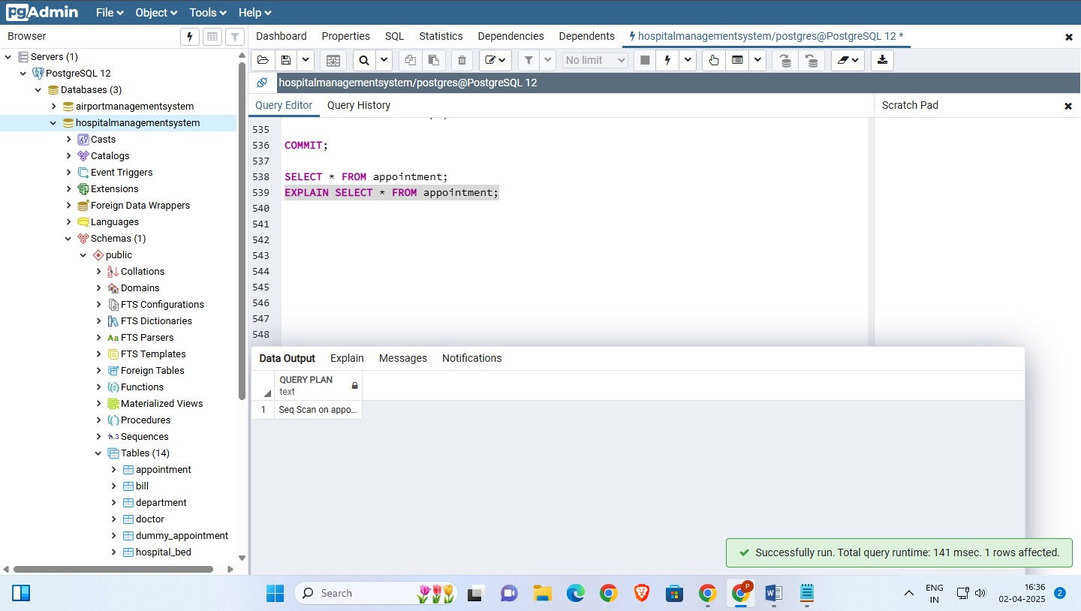
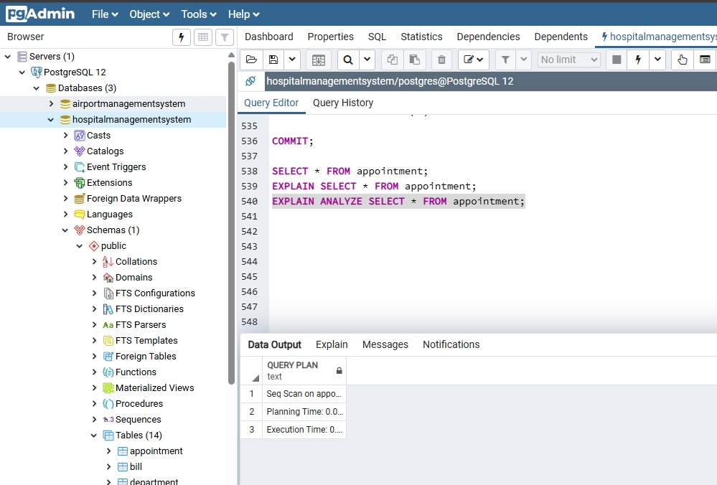

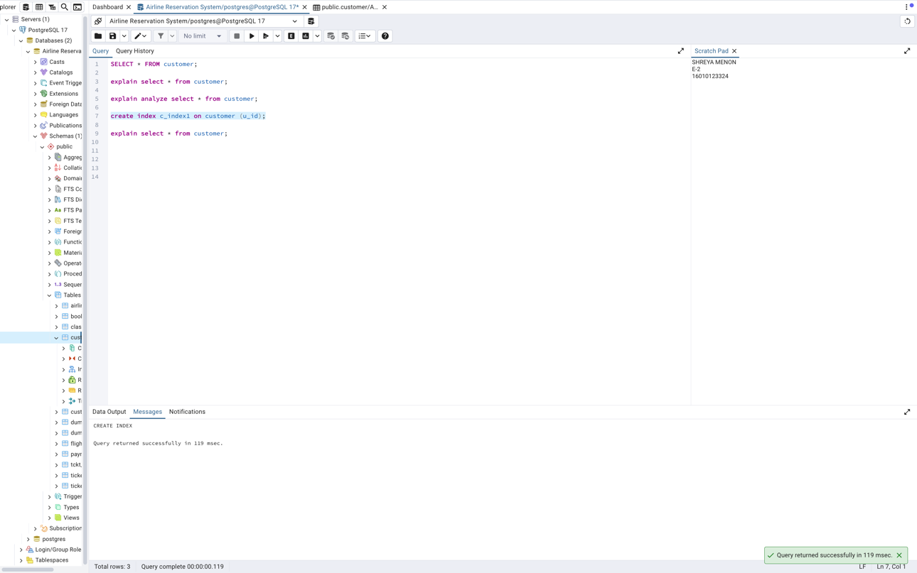

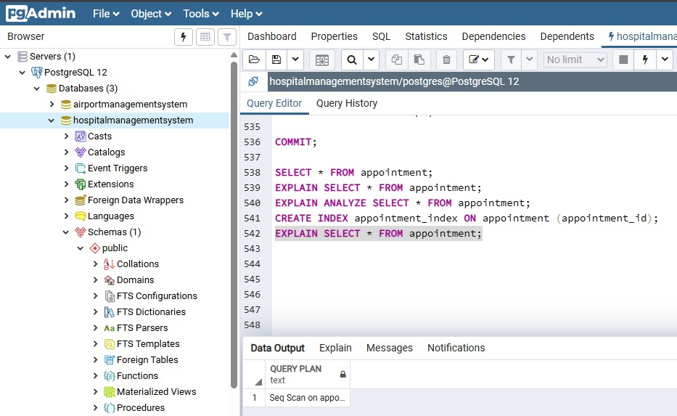

  - Select query with where clause

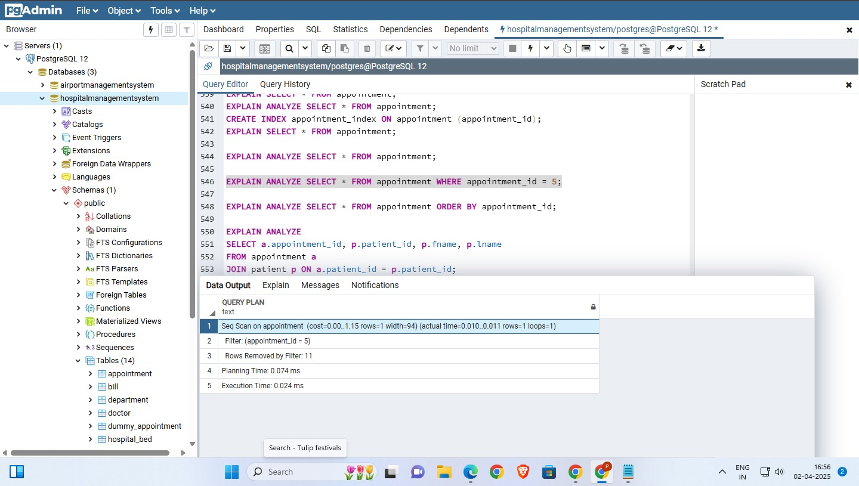

  - Select query with order by query

  - Select query with JOIN

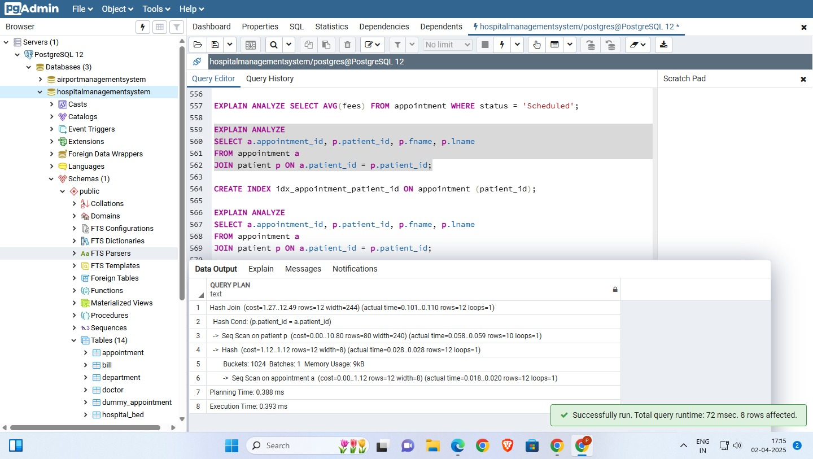
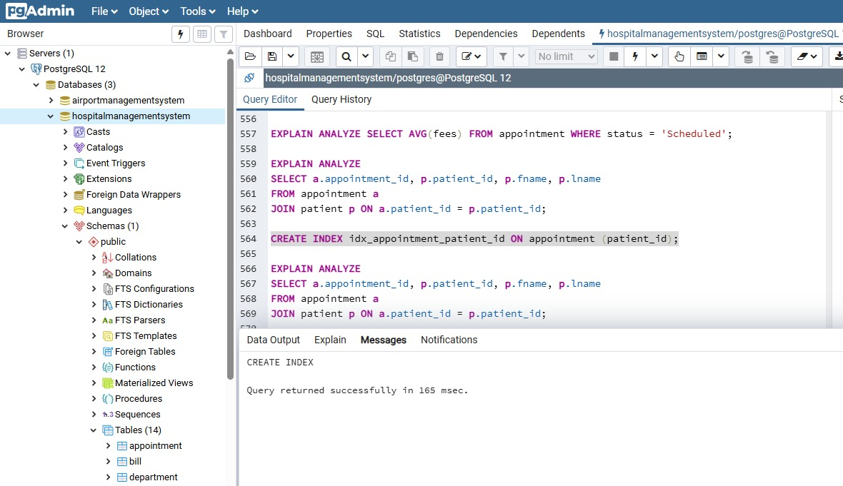
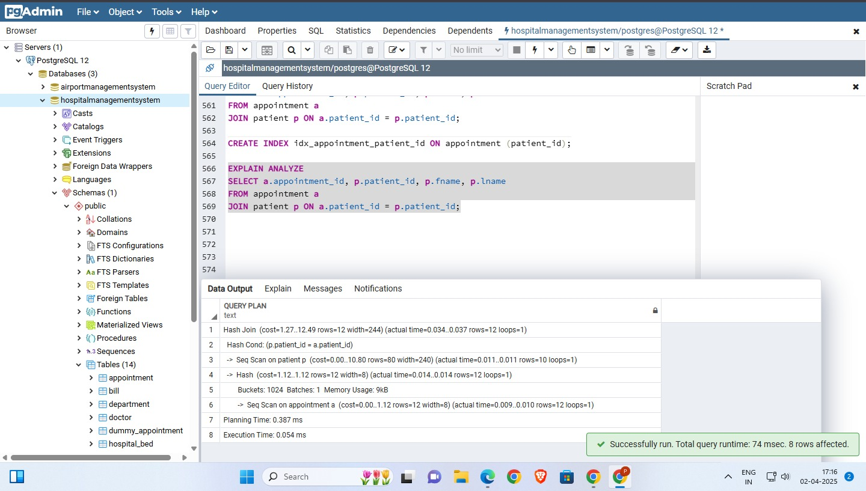

  - Select query with aggregation

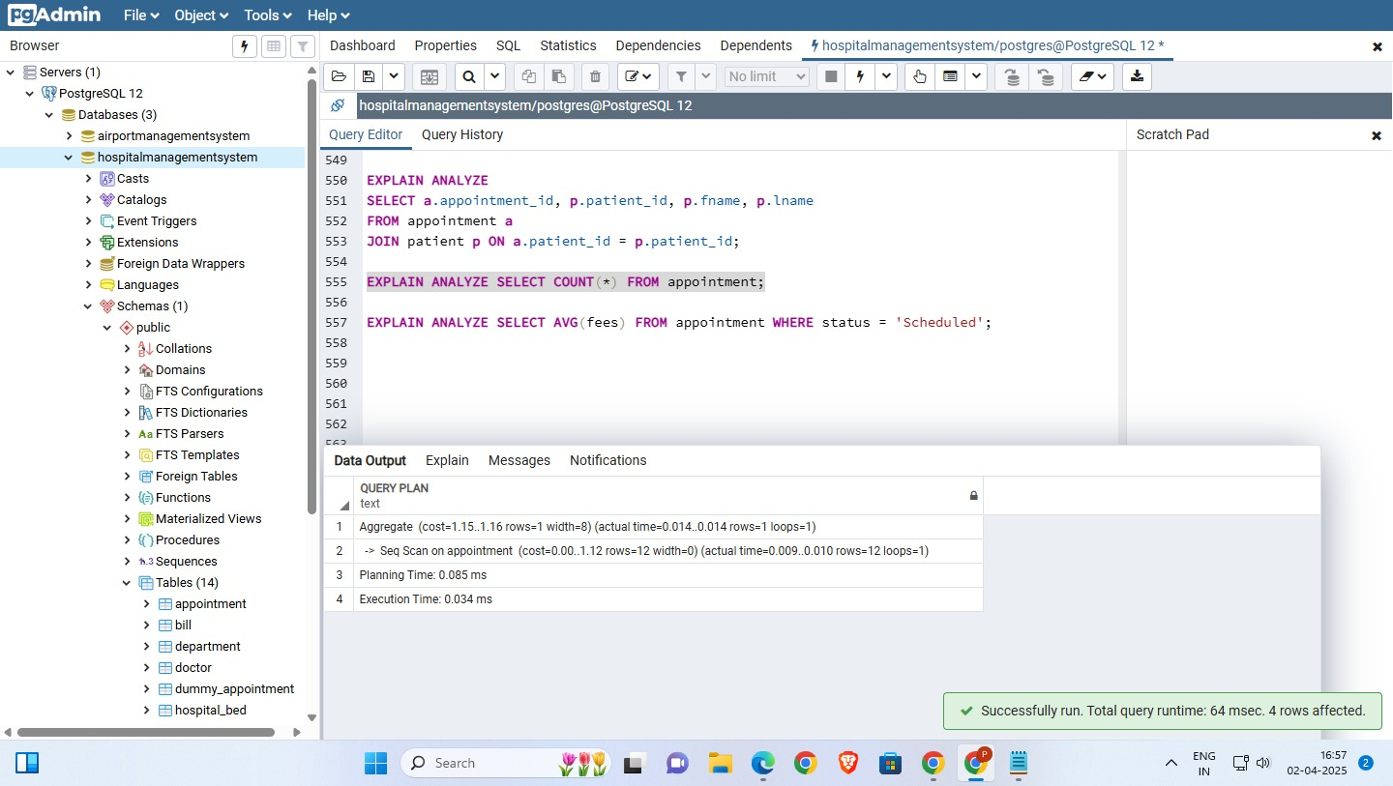

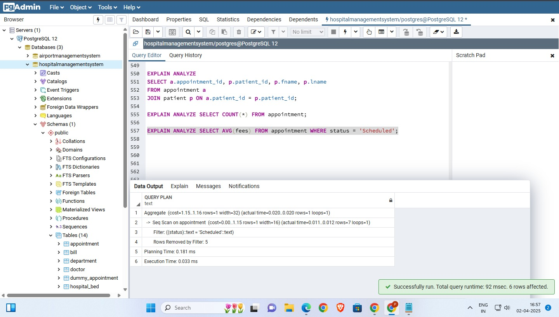

Post Lab Question:

- How does a B-tree differ from a B+-tree? Why is a B+-tree usually preferred
as an access structure to a data file?

A B-tree stores keys and data in both internal and leaf nodes, leading to varied search paths. In contrast, a B+-tree keeps data only in leaf nodes, while internal nodes store keys for navigation, ensuring uniform access time. Additionally, B+-trees have linked leaf nodes, enabling faster range queries. Due to efficient search performance and optimized disk I/O, B+-trees are preferred for database indexing and file systems.

Preferred because-
• Efficient Range Queries: Since leaf nodes are linked, B+-trees allow sequential access to records, making them ideal for range queries (e.g., retrieving records in a sorted order).
• Uniform Access Time: In B+-trees, all searches fetch data from leaf nodes, leading to more predictable and optimized disk I/O.
• Better Space Utilization: Internal nodes only store keys, making them more compact and reducing the height of the tree, leading to faster searches.
• Efficient Insertion & Deletion: Since modifications mostly happen at the leaf level, restructuring is minimized, leading to better performance in dynamic databases.

Conclusion:
The above experiment deals with creation of relevant indexing for different tables in the database, and analysing the statistics with and without use of indexing.

